2015 Tri-State Leadership Conference

Affiliate of the Society for Human Resource Management

August 6th, 2015

Sheraton Portsmouth Harborside

8:00 AM – 4:00 PM

Join the excitement and exclusive premier event for HR Professionals representing the *TOP 100 HR Professionals* in leadership roles across Maine, New Hampshire, and Vermont on each of their State Councils and Committees.

***To register for the conference:***

<http://nhstatecouncil.shrm.org/events>

*Conference fee: $65*

|  |  |  |
| --- | --- | --- |
| Keynote: Andrew Morton, Director Social Engagement, Society for Human Resource Management | Who Should Attend? | Keynote: Don MacPherson, President, Modern Survey |
| Andrew Morton serves as the Director of Social Engagement at SHRM.  He is marketing and PR executive who’s led public and private organizations to unprecedented levels of brand awareness through interactive strategic communications practices in traditional and new media. | * State Council Members * Chapter Board & Committee Members * Prospective Volunteers | Don MacPherson is an employee performance expert with over 17 years of industry experience. As President of the human capital measurement company, Modern Survey, Don oversees the organization’s consulting and employee measurement practices. Don’s areas of expertise include understanding employee and customer motivations, developing effective leadership, and creating processes for gathering employee feedback. |

[](http://www.cgibusinesssolutions.com/)

H:\HR State Council\Tri-State Conference 2015\Sponsorships\Logos\Cross Insurance.gif

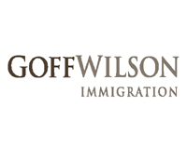

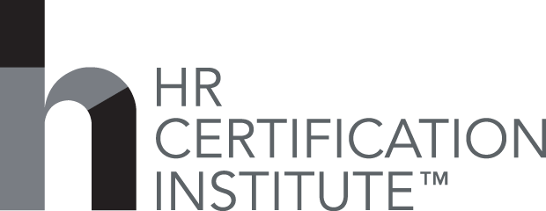

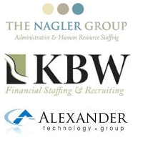

H:\HR State Council\Tri-State Conference 2015\Sponsorships\Logos\Northeast Delta Dental.jpg

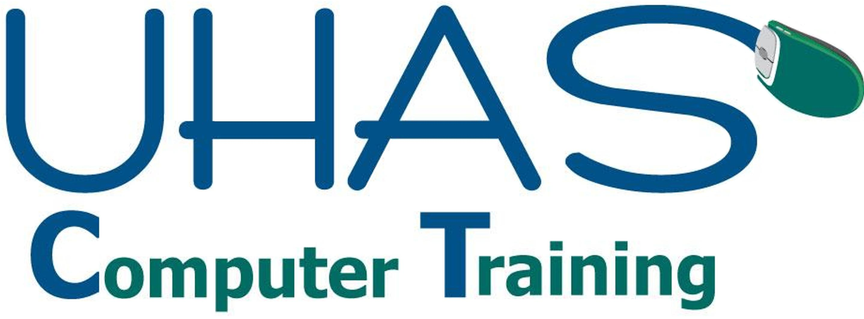

Follow us:

#TriStateHR_NE

@NH_SHRM

@MaineSHRM

@SHRMSocial

@MacPherson_D